Brochure Image & Text Extraction
Coast Underground / Mainstay / Insta-Valve
Extracted images and brochure text organized by matching section headings. Image filenames are listed under each heading so the text can be matched back to the delivered image set.
Item | Details
Image count | 16
Source | Uploaded brochure images
Output folder | coast-underground-brochure-extracted-images

How It Works - Before Corroded Manhole
Image file: before-corroded-manhole.jpg
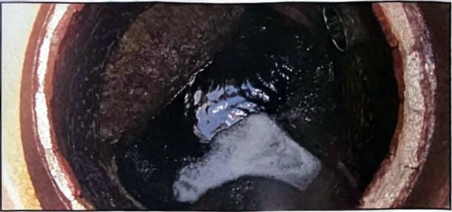
Sulfuric acid attacks concrete and brick mortar, compromising the integrity of the structure.

How It Works - After Restored Manhole
Image file: after-restored-manhole.jpg
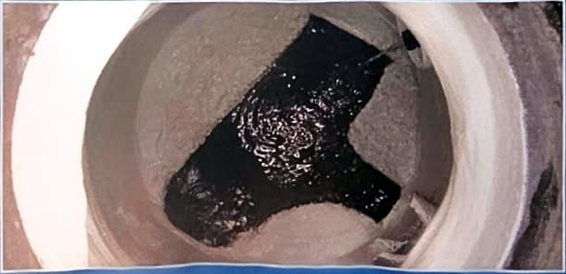
- Mainstay ML-72 mortar restores deteriorated concrete and brick surfaces.
- Mainstay 100% solids epoxy coatings prevent future attack.
- Most structures may be restored, protected, and placed back into service within 24 hours.

Mainstay Composite Liner Logo
Image file: mainstay-composite-liner-logo.jpg
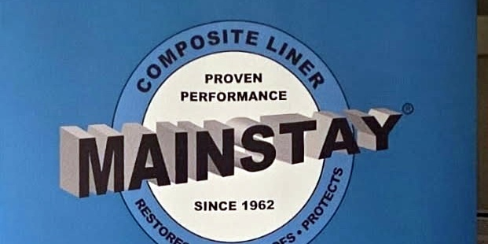
Mainstay Composite Liner. Proven performance since 1962. Restores, waterproofs, protects.

Composite Liner Field Application - Brick Structure
Image file: field-application-brick-structure.jpg
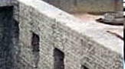
Restoration and corrosion barrier composite liner application imagery for structural rehabilitation.

Composite Liner Field Application - Channel Wall
Image file: field-application-channel-wall.jpg
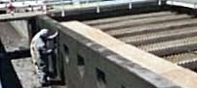
Composite liner restoration shown on a channel or containment wall surface.

Composite Liner Field Application - Spray Application
Image file: field-application-spray-application.jpg
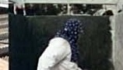
Spray application of corrosion barrier liner material in a rehabilitation setting.

Restoration and Corrosion Barrier Composite Liner
Image file: restoration-corrosion-barrier-composite-liner.jpg
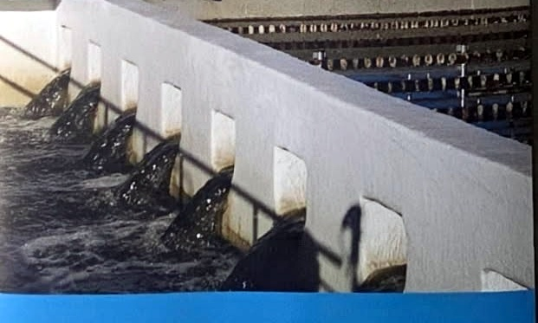
Restoration and Corrosion Barrier Composite Liner.
- Manhole Rehabilitation
- Potable Water Linings
- Application Equipment

Madewell Products Corporation Logo
Image file: madewell-products-logo.jpg
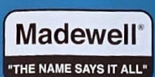
Madewell. "The name says it all."

ML-72 Horizontal Pipe Restoration - Before
Image file: ml72-horizontal-pipe-before.jpg
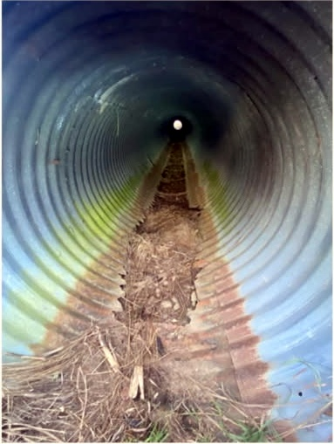
Best to stay ahead of pipe decay versus behind. Before image showing pipe decay/debris prior to ML-72 horizontal pipe restoration.

ML-72 Horizontal Pipe Restoration - After
Image file: ml72-horizontal-pipe-after.jpg
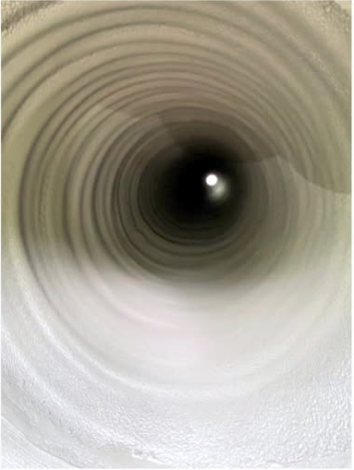
After image showing restored horizontal pipe interior following ML-72 restoration.

Step 1 - Substrate Preparation
Image file: step-1-substrate-preparation.jpg
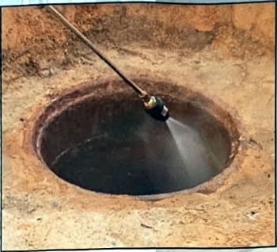
Prepare deteriorated substrates by any effective combination of water blasting, pressure washing, abrasive blasting, acid etching, or power tool cleaning.

Step 2 - ML-72 Mortar Application
Image file: step-2-ml72-mortar-application.jpg
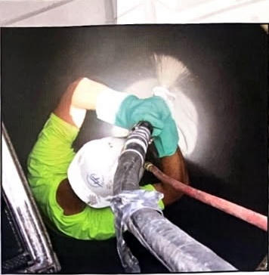
Apply Mainstay ML-72 mortar to the substrate using shotcrete equipment, a trowel, or the Mainstay Mortar Spinner.

Step 3 - DS-5 Epoxy Application
Image file: step-3-ds5-epoxy-application.jpg
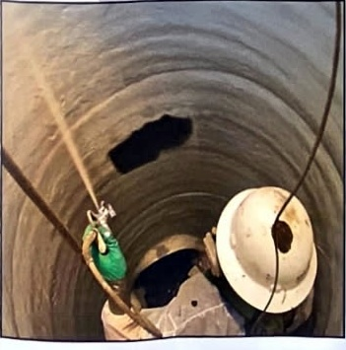
Apply Mainstay DS-5 epoxy to the mortar while it is still soft enough to indent with a fingertip.

Insta-Valve Plus - Excavation Overview
Image file: insta-valve-plus-excavation-overview.jpg
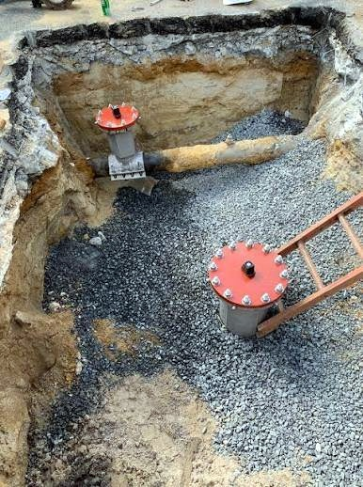
Field reference photo showing an excavated underground valve installation area with gravel bedding/backfill, existing pipe exposure, and valve access assemblies visible.

Insta-Valve Plus Features Diagram
Image file: insta-valve-plus-features-diagram.png
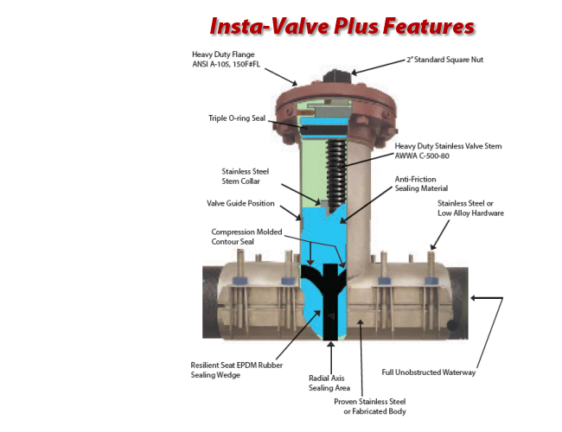
Insta-Valve Plus Features.
Feature labels shown in the diagram:
Heavy Duty Flange - ANSI A-105, 150#FL. | 2 inch Standard Square Nut.
Triple O-ring Seal. | Heavy Duty Stainless Valve Stem - AWWA C-500-80.
Stainless Steel Stem Collar. | Anti-Friction Sealing Material.
Valve Guide Position. | Stainless Steel or Low Alloy Hardware.
Compression Molded Contour Seal. | Resilient Seat EPDM Rubber Sealing Wedge.
Radial Axis Sealing Area. | Full Unobstructed Waterway.
Proven Stainless Steel or Fabricated Body.

Insta-Valve Plus - Trench Installation
Image file: insta-valve-plus-trench-installation.jpg
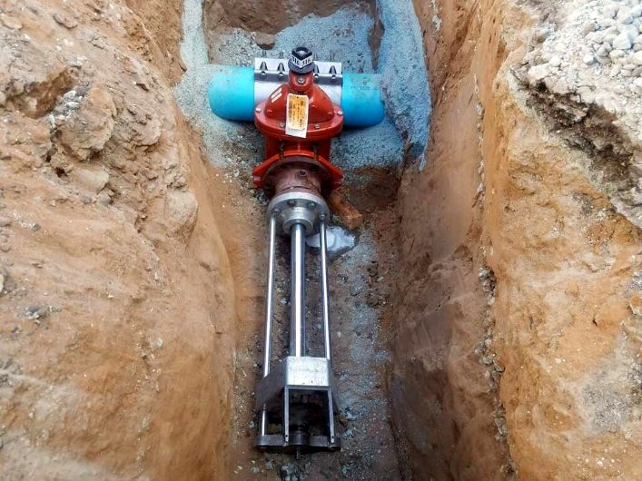
Field reference photo showing an Insta-Valve Plus installation in a trench, with the valve body mounted on the pipe and installation equipment aligned in the excavation.

